Earth-Atmosphere Interactions: Tropical Storm and Hurricane Activity in the Caribbean and Consequent Health Impacts

Jenni L. Evans
Pennsylvania State University

Jose D. Fuentes
Pennsylvania State University

Xiao-Ming Hu
Pennsylvania State University

Holly Hamilton
Pennsylvania State University

Hurricanes represent the most majestic weather features of the Earth’s atmosphere. Yet, due to their sheer size and excessive winds and rainfall, hurricanes cause devastation in populated areas, including destruction of community infrastructure and spread of infectious diseases. Here we review the necessary conditions required for the formation of tropical storms in the North Atlantic Ocean, with particular emphasis on those tropical cyclones that routinely impact the Caribbean basin. Briefly, for tropical storms to form it is necessary to have, warm ocean conditions, light winds without much variability with altitude, and atmospheric conditions suitable to promote and sustain thunderstorm activity. In addition, we examine the historical hurricane record for the last 110 years to identify the variability and the cycles in tropical storm activity impacting the Caribbean basin. The record shows highly variable tropical storm activity in the Caribbean. During the early part of the 1900s, tropical storm activity reached maximum levels, then was suppressed during the 1930s to 1980s, returning to peak tropical storm activity during the period 2000-2009. Only 6 of the 110 years examined did not register tropical storm activity impacting the Caribbean basin! The El Niño Southern Oscillation (ENSO) phenomenon modulates the tropical storm activity. During ENSO events, tropical cyclone activity diminishes over the Caribbean basin. Trends in the number of storms in response to warming are difficult to discern. However, in response to atmospheric warming, it is anticipated that tropical storm activity will decrease in the Caribbean basin. Given that future atmospheric warming can engender more extreme weather events, the strongest storms that form in a warmer climate will likely become more intense. Analyses of the historical records, such as those presented here, can assist policy makers and health providers in planning for future tropical storm activity. Previous frequency of storm occurrences and storm trajectory paths are all relevant to the development of future strategies to minimize storm devastation and prepare for the delivery of timely health care to impacted communities. In addition, historical records can provide insights into interannual variability and can assist in building an infrastructure to withstand or minimize tropical storm impacts on both human health and destruction of private property. Planning and implementation of improved strategies will add resilience to the communities along the main storm trajectories in the Caribbean basin. Synergies among health providers and meteorologists will prove invaluable to optimize the delivery of health care and minimize the spread of infectious diseases in regions such as the Caribbean basin.

CARIBBEAN VULNERABILITY
Tropical cyclones (known as hurricanes in the North Atlantic Ocean) regularly wreak devastation on communities throughout the tropics, and sometimes even at higher latitudes. Records of hurricane impacts in the Caribbean go back hundreds of years (e.g. De Souza, 2001; Chenoweth and Divine, 2008). During a hurricane landfall or close approach to land, fatalities and damage to property and infrastructure can result from the strong winds and copious rain (e.g. Schultz et al., 2005; Jonkman and Kelman 2005). Strong winds can directly damage structures or propel debris; intense rain can cause flooding (due to salt water inundation from storm surge or fresh water flooding along waterways) and landslides.
Immediately after hurricanes, electric power, public transportation and associated infrastructure (roads, bridges, etc.), and health services are disrupted. Medium-term consequences of the hurricane can further devastate communities (e.g. Schultz et al., 2005): standing water can provide the ideal environment for the unchecked breeding of mosquitoes and spread of vector-borne diseases, and consumption of contaminated water can cause gastrointestinal diseases. Untreated injuries, lack of food and fresh water and trauma are further sources of societal suffering (e.g. WHO, 2006 and 2008). Hurricane events are a regular occurrence in the Caribbean: the continued suffering in Haiti after the 2010 earthquake followed by Hurricane Tomas (NHC, 2010a), the repeated landfalls of Hurricane Georges (Guiney, 1999) (Fig. 1) and the four hurricane landfalls on the island of Hispaniola in 2008 remind us of the societal consequences regularly caused by hurricanes in this region.
From this perspective, tropical cyclones are both a direct and an indirect health hazard. We must conceptualize disasters not just in terms of the event itself, but including the processes that set them in motion and the post-event processes of response and recovery (Oliver-Smith, 2006). A prime example of this in the United States was Hurricane Katrina in 2005, which turned out to be a disaster for New Orleans and surrounding areas because of the event itself and the flawed responses that ensued. This disaster demonstrated how oftentimes the effects of disasters vary across lines of difference, disproportionately affecting certain vulnerable populations. Those subject to the impact of disasters are not a homogeneous “victim” group. Rather, differences in terms of gender, class, socioeconomic status, race/ethnicity, age, physical and mental ability, and culture in some cases compound the impact of a disaster (Fordham, 1999). Differences between such social groups sometimes predict recovery outcomes (see Bolin, 1986).
While the immediate consequences of a tropical cyclone landfall can only be partially mitigated, the possibility exists for greatly reducing the indirect loss of life to disease by advance planning. An understanding of the relative susceptibility of a location to hurricanes and the factors determining their long- and short-term variations provides a useful background in marshalling resources to reduce societal vulnerability to this peril. The concept of vulnerability links environmental hazards to societal forces in order to explain “how conditions such as poverty or racism produce susceptibilities to very specific environmental hazards” (Oliver-Smith, 2006). Vulnerability refers to “the totality of relationships in a given social situation producing the formation of a condition that, in combination with environmental forces, produces a disaster” (Ibid.).
In this paper, we review the conditions under which hurricanes form and then discuss the atmospheric patterns leading to changes in hurricane activity (number of storms passing through the region) in the western and eastern Caribbean (Fig. 2) during the last 110 years. Finally, we explore the possible past and future trends in hurricane activity in the Caribbean basin.

FACTORS GOVERNING TROPICAL CYCLONE FORMATION AND VARIABILITY IN THE NORTH ATLANTIC

It is not an easy matter for a hurricane to form, which is why the long-term average for the North Atlantic is only about 11 hurricanes annually (NHC, 2010b). For a hurricane to form, a weak disturbance must first form in a broad region of active thunderstorms and warm ocean conditions. The warmest ocean conditions are near the Equator, however tropical cyclones do not form close to the Equator due to the effects of the Earth’s rotation there. Finally, the winds circulating around the developing storm should not change very much with height or they will rip the system apart before it gains strength. In summary, then, the ideal environment for formation of a tropical cyclone arises from a convergence of (i) an initial weak cyclonic disturbance (i.e. counterclockwise air circulation in the Northern Hemisphere), (ii) a region of warm ocean conditions that is not too close to the Equator, (iii) weak winds that do not change much with height (weak “vertical wind shear”) and (iv) a broad-scale amount of thunderstorm activity (Gray, 1968 and 1979; Rappin et al., 2010). However, even if all four of these conditions are present, a tropical cyclone may not form: they are simply necessary, but not sufficient conditions. Thus, the complete set of sufficient conditions for hurricane formation has not yet been identified.
After its genesis, the storm system is known as a tropical depression until its intensity (measured by its strongest winds near the surface) exceeds 39 miles per hour (mph); once the system exceeds this wind threshold, it is labeled a tropical storm (Evans, 2010) and is assigned a name by the National Hurricane Center (NHC). As a storm intensifies further, it is classified as a hurricane and assigned a category based upon its maximum wind speed (NHC, 2010c). Once the tropical cyclone is formed, its motion is dominated by the large-scale winds in the storm environment “steering” it (the effects of the Earth rotation also have a small effect). Large-scale winds and effects of Earth rotation can transport a tropical cyclone from its genesis location to our region of interest, the Caribbean (Fig. 3). Along the way, variations in the same atmospheric conditions needed for tropical cyclone formation will cause the storm to strengthen or weaken and may also affect its size. These changes influence the spatial and temporal distribution of the severe weather associated with the storm.
The environment in which a tropical cyclone forms changes continuously, but we can also identify specific (longer) periods of time when systematic changes in the environment make it more or less favorable for storm formation. For example, the Madden-Julian Oscillation (MJO) is a roughly 4-6 week fluctuation in the tropical wind patterns over an area of thousands of kilometers (Madden and Julian, 1994). These changes in the winds influence the amount of thunderstorm activity and so render the conditions needed for storm formation more or less favorable. These studies of short-term variability help us to identify the types and magnitudes of changes in the environment that can effect changes on tropical cyclone formation likelihood, and inform our investigations of longer-term (years to centuries) tropical cyclone variability and trends. The El Niño Southern Oscillation (ENSO) phenomenon has also been shown to affect the incidence of tropical cyclones from year to year (Sabbatelli and Mann, 2007). While the links are complex, a relationship between North Atlantic hurricane activity and ENSO incidence has been established: there are less tropical cyclones during ENSO years (on average, of course). This basin-wide relationship is quite robust, especially for moderate to strong ENSO years. However, the frequency and strength of ENSO years varies from decade to decade (Table 1), due in part to the North Atlantic Oscillation (NAO) (Giannini et al., 2001). As we shall see this is reflected in the variability of tropical cyclone activity in the Caribbean basin.

CURRENT CLIMATE OF THE CARIBBEAN
The Caribbean has a wet/dry (rather than warm/cool) climate: dry in winter and wet in summer. During June to November each year, easterly waves form off the coast of West Africa and often cross the Atlantic Ocean into the Caribbean; indeed, they represent the primary rainfall source for the region at the wettest time of the year. These waves frequently mature into tropical cyclones in the latitude band ranging from 10°N to 20°N, especially if they are evolving in a favorable environment with high (> 25 º C) sea surface temperature (SST) and low vertical wind shear.
Inter-annual variability of the rainfall is influenced mainly by ENSO events through their effect on SST in the Atlantic and Caribbean Basins. The late rainfall season tends to be drier in El Niño years and wetter in La Niña years (Giannini et al., 2000) and tropical cyclone activity diminishes over the Caribbean during El Niño summers (Gray, 1984). However, the early rainfall season in the central and southern Caribbean tends to be wetter in the year after an El Niño and drier in a La Niña year (Chen and Taylor, 2002). On shorter timescales, hurricane incidence in the western Caribbean has been linked to the MJO (Maloney and Hartmann, 2000). On longer timescales, the inter-decadal variations in frequency and strength of ENSO years are reflected in the long-term variability of tropical cyclone activity in the Caribbean basin (Section 5.3).

RESEARCH METHODOLOGY
Hurricanes impact the nations of the Caribbean regularly in the current climate. So the question arises: “How might hurricane activity and intensity change in a warmer mean climate?” Hurricane formation and motion depend on large-scale weather patterns and ocean temperatures across the Atlantic. We will show here that changes in the these atmospheric and oceanic conditions lead to variations of hurricane activity over years and decades, and these variations are evident in the Caribbean storm record. Understanding the underlying causes of these changes will give us the tools to explore potential changes in Caribbean hurricane activity in response to global climate change.
Our first step is to examine the historical records of tropical cyclone (tropical storm and hurricane) activity for the 1900-2009 period, both on the North Atlantic and local Caribbean basins (NHC, 2011). Then, we explore the spatial extent of the atmosphere that corresponds to hurricane activity in the Caribbean and the winds experienced in the region due to hurricane passage (NCEP, 2010). Finally, we consider the modulation of hurricane activity by the (Atlantic basin focused) Saharan Air Layer (SAL) and the (global) ENSO phenomena (NOAA, 2010a), before extending our understanding of the drivers of hurricane formation into the realm of climate change.

VARIABILITY OF TROPICAL CYCLONE INCIDENCE AFFECTING THE CARIBBEAN BASIN
The incidence of these events is unevenly distributed in time, but their important societal impacts have led to efforts to forecast these systems since time immemorial. In the Caribbean, formal records of tropical cyclone occurrence have been kept since Padre Benito Viñes attempted to forecast the arrival of storms. The first to combine traditional observing practices with modern quantitative methods was Padre Benito Viñes (Fernández Partagás and Diaz, 1996; Viñes 1877 and 1895), who developed a systematic method of operational hurricane forecasting in Cuba during the 1860s. Padre Viñes’ forecasting approach (Viñes, 1898) informed the first hurricane warning procedures for the US National Weather Service (NOAA, 2010b). In only six of the past 110 years was the Caribbean spared from the passage of at least one tropical cyclone (Fig. 3). Thus, in this section we will explore the spatial and temporal variations of hurricanes affecting the Caribbean and relate these variations to the large-scale weather and ocean patterns of the region.

Climatology of tropical cyclone activity impacting the Caribbean
Tropical cyclones impacting the Caribbean basin generally form in the far eastern Atlantic Ocean (Fig. 3). Partitioning the tracks of hurricanes (category 1 or greater) that affected the western and eastern Caribbean (Fig. 3, left and right columns, respectively) reveals that many of the weaker storms impacting one region do not impact the other (compare Figs. 3b and 3c), whereas almost all of the category 2 or stronger hurricanes impact nations in both the western and eastern Caribbean (Figs. 3d–3g; Fig. 1). Contrasting the mean storm tracks depicted in Fig. 3 with the climatological “most likely” tracks by month (Fig. 4) emphasizes the increased risk of hurricane passage in the peak hurricane season months of August through October (Fig. 4). In August and September, hurricanes most often form in the “Main Development Region (MDR)” off west Africa and increase in intensity (stronger winds) as they traverse across the tropical Atlantic Ocean, often arriving in the Caribbean region packing “plenty of punch” (Fig. 5).
The situation is somewhat different in October: the majority of hurricanes form in the Gulf of Mexico and have much less time to intensify before they reach the western Caribbean; in contrast, these storms rarely affect the eastern Caribbean (compare Fig. 3 right panels and Fig. 4).

Environment favorable for tropical cyclone activity in the Caribbean
To understand the factors governing the development of tropical cyclones in the North Atlantic and their passage through the Caribbean, we examine the average North Atlantic weather patterns in the peak of the hurricane season (Fig. 6).
Tropical cyclones impacting the Caribbean predominantly form off the west coast of Africa in the months of August through October (Figs. 3, 4 and 6). Throughout these months, the Bermuda High is strong, but is further north than in the remainder of the year. This means that lower pressures generally prevail in the Atlantic south of about 30 °N. These lower pressures also lead to weaker vertical wind shear near the Equator than at other times of the year. Finally, the ocean temperatures in the Caribbean exceed 27 °C, a critical threshold for the reliable development of active thunderstorms. These factors satisfy the necessary conditions needed for tropical cyclone formation preferentially off West Africa, where the ocean temperatures also exceed the critical 27 °C threshold and the low pressures (dark contour roughly outlining the African coastline) signify the presence of the West African monsoon. These same factors also combine to create an environment favorable for tropical cyclone intensification as they cross the near-equatorial region of the North Atlantic on their passage towards the Caribbean basin.
If tropical cyclones follow such clear-cut patterns, then why are they so difficult to forecast? Confounding factors, such as the dry air of the Saharan Air Layer, SAL (Fig. 7), small regions of cool ocean water or large vertical wind shear (the latter known as “jets”), interactions with land or other weather systems all complicate the evolution of individual tropical cyclones. Substantial progress is being made on pinning down each of these complicating factors. For example, the SAL occurs when dust storms from the Saharan desert create deep layers of dry and dusty air that are carried over the North Atlantic Ocean (Braun, 2010; Dunion and Velden, 2004). Interactions between weather systems in the tropics and at higher latitudes transport this dust in complicated ways (Fig. 7). Because of its temperature and moisture content, the SAL is a region of strong vertical wind shear, so it carries with it two negative influences on a tropical cyclone: the dry air and the large change of wind speed with height. Satellite diagnostics (Fig. 7) are used to observe the SAL (Dunion and Velden, 2004) and resulting information is fed to numerical models to forecast evolution of tropical storms. This approach aids in understanding and forecasting the influence of the SAL on tropical cyclone lifecycles.
In a similar fashion, satellites can be used to track the spatial and temporal variability of ocean temperatures (Fig. 6) and also the three-dimensional atmospheric wind patterns.
Through the combination of observational and computer modeling technologies, theoretical model development and physical insight, our understanding of the complex factors governing the evolution of individual tropical cyclones has advanced over recent decades. This understanding gives us a framework for relating the systematic changes in the atmosphere and oceans due to ENSO and other climatic signals with longer-term variations in tropical cyclone activity. We will use this to our advantage now in examining the influence of ENSO on Caribbean storminess.

Temporal variations in tropical cyclone activity impacting the Caribbean
As noted above, inter-annual tropical cyclone frequency (Fig. 8) and track variations are evidence of climate-scale modulation of weather in the global tropics. Global-scale changes in the atmosphere and oceans in response to the phases of the ENSO modulate the inter-annual frequency of North Atlantic tropical cyclones (e.g. Goldenberg and Shapiro, 1996; IPCC, 2007a and b; Sabbatelli and Mann, 2007). Other influences, such as the location and strength of the African monsoon, have also been linked to changes in North Atlantic tropical cyclone activity (Landsea and Gray, 1992) and even to subsequent US landfall locations (Gray and Landsea, 1992). The North Atlantic Oscillation (NAO) modifies these other signals over timescales of decades.
The impacts of these global climate signals are even evident over a region as small as the Caribbean. This is evident from a comparison of the surface wind, temperature and pressure patterns averaged only over ENSO years (Figs. 9b and 9c, Table 1) with the same patterns for all years (Fig. 6b). The large region of high pressure (around 1020 mb) in the northeast of the North Atlantic is the Bermuda high. In ENSO years (Fig. 9c), the Bermuda high gets stronger than normal, and extends a further westward into the Caribbean basin. Since the Bermuda high is the dominant weather feature for steering tropical cyclones in this region, these changes result in stronger winds from the east and so we see changes in the tropical cyclone tracks (Fig. 9a). These changes in pressure coincide with a slight cooling (about 0.5° C) of Caribbean ocean and a similar magnitude of warming in the waters of the northern Gulf of Mexico and east of Florida.
Examination of tropical cyclone and ENSO frequency by decade (Fig. 10) does not present a simple picture to explain long-term Caribbean tropical cyclone variability, although the persistent differences between the western and eastern Caribbean throughout the decades is noteworthy. Tropical cyclone activity in the western Caribbean was at a peak in the 1930s, dropped until the 1980s and built back to 1930s levels in the decade since 2000 (Fig. 10a). Activity in the eastern Caribbean differed from the west, apparently breaking down into three distinct phases: an active period in the 1930s through 1950s and again since 1990, with three decades of relatively low activity in the 1960s through 1980s. Interestingly, the phases of the eastern Caribbean generally correspond to active and inactive ENSO decades (Fig. 10b). Giannini et al. (2001) propose that differences in the impacts of ENSO on Caribbean rainfall in the last two decades compared to earlier times are due to changes in the phasing of the NAO and ENSO during these decades. Only the years 1980-2009 were used in the analyses presented in Fig. 9, so these spatial patterns cannot be used to describe variability in the earlier decades depicted in Fig. 10. These decadal-scale variations of tropical cyclone incidence in the western and eastern Caribbean regions are consistent with long-term changes in North Atlantic hurricane activity (e.g. Landsea et al., 1992; Goldenberg et al., 2001).

Detection of long-term trends in observed tropical cyclone activity
Long-term variations in the numbers of North Atlantic tropical cyclones (HURDAT; NHC, 2011) have generally been attributed to various climate cycles. However, the long-term changes already observed may also have been contributed to, at least in part, by the atmospheric and oceanic response to global warming (Mann and Emanuel, 2006). We will return to consideration of global warming later.
Landfall statistics in populated regions are robust since people were affected by landfalls and left diaries and other reports of their misadventures (Landsea, 2007). In contrast, the lack of observations out to sea leads to uncertainties in the annual numbers of North Atlantic tropical cyclones in the pre-satellite era (Landsea et al., 2006). Efforts have been made to account for these uncertainties in storm numbers out to sea by mimicking the regions covered by ship tracks in earlier times to sample the storm tracks over the last 30 years to develop probabilities of detection in the earlier part of the record (Mann et al., 2007; Vecchi and Knutson, 2008; Landsea et al., 2010).
The short period of record spanned by the historical hurricane database (NHC, 2011), and the even shorter 30-year period of the satellite era, lead us to explore additional lines of evidence through history for annual tropical cyclone frequency, as well as trends and variations. One approach to extending the historical records is through construction of multi-century proxy records (Donnelly and Woodruff, 2007; Nyberg et al., 2007). Sand deposits in coastal lakes due to storm passage have been used to develop proxy records of storm activity, and possibly even intensities of those storms. One major caveat is that a limited number of locations have been sampled to date, so it is not yet possible to deconvolve changes in annual – or even decadal – tropical cyclone frequency from changes in their average tracks. Since the region currently surveyed is so small geographically, any trends observed here cannot be generalized to the entire North Atlantic basin. Even systematic changes in Caribbean landfalls may just reflect a change in storm tracks over the period of study rather than a change in tropical cyclone numbers across the basin. Still, these studies are a different and fresh approach, providing an additional contribution to the interpretation of the available record and many (e.g. Donnelly and Woodruff, 2007 in Puerto Rico) are being undertaken in the Caribbean region.

POSSIBLE CHANGES IN CARIBBEAN TROPICAL CYCLONES DUE TO GLOBAL WARMING
Having reviewed the factors affecting tropical cyclones during the present climate, we next consider the projections of climate change relevant to the Caribbean as agreed in the most recent review by the Intergovernmental Panel on Climate Change (IPCC, 2007a and b). Utilizing these combined resources, we develop projections of Caribbean tropical cyclone changes due to global warming. In the final section of the paper we will summarize these changes in the context of health impacts.

IPCC climate change projections relevant to the Caribbean
Here we review the IPCC (2007a) projections of regional climate changes relevant to the Caribbean. The IPCC expresses confidence in their projections and employs terminology that can be equated to probability of occurrence using the following scale: Virtually certain > 99%, Extremely likely >95%,Very likely (VL) > 90%, Likely (L) > 66%, More likely than not (medium confidence, M) > 50%, Unlikely (U) < 33%, Very unlikely (VU) < 10%, Extremely unlikely < 5% (IPCC, 2007b).
Caribbean islands are very likely to warm during this century (1.3°−3.4° C, IPCC 2007a Table 11.1), but this warming is likely to be smaller than the global annual mean temperature. Summer rainfall in the Caribbean is likely to decrease in the vicinity of the Greater Antilles but changes elsewhere (and in winter) are uncertain (the median decrease is 12 %, but model scenarios range from a 58 % decrease to 19 % increase; IPCC, 2007a; Table 11.1); these precipitation changes may translate to a 20-40 % increase in dry summer (JJA) and fall (SON) seasons.
Finally, on average sea levels are likely to rise during this century in the Caribbean Sea; this rise will likely not be geographically uniform but large deviations among model predictions make estimates across the Caribbean uncertain. Sea level rise is of general concern as, in addition to the direct loss of coastal lands, rising sea levels shrink the available fresh water lens for island nations, thereby reducing potable water supplies. In the context of tropical cyclones, sea level rise can lead to storm surge inundation into previously safe regions. This can also affect freshwater flooding, since runoff from the rains drains into the rivers, which ultimately empty into the sea; storm surge “piles up” water at the mouths of the rivers, preventing the rivers from draining and causing the waters to spread out into freshwater floods.

Projections of changes to Caribbean tropical cyclones due to climate warming
The IPCC has made conclusions on tropical cyclone changes due to global warming (summarized in Table 2), but confines these conclusions to general statements on global trends (IPCC, 2007a). Here we will combine our previous discussion on factors affecting tropical cyclones with detailed results from Global Climate Model (GCM) projections of features of the future climate important to tropical cyclones. Over thirty separate modeling groups contributed to reports on global climate change (IPCC, 2007a and b), providing a resource for our exploration.
Our decadal analyses were suggestive of a direct link between ENSO and Caribbean tropical cyclone activity (more Caribbean storms in an ENSO phase on average), so we ask what happens to ENSO in a warmer climate? Unfortunately, the answer is not clear. The news on ENSO from the GCM is mixed: many models project more ENSO events, and even go as far as suggesting that the climate may be more “ENSO-like” on average, but concerns with details of the representation of clouds in the models require caution using these results.
Why not just count the number of “tropical cyclones” predicted in each GCM? This is because while the GCMs are generally reliable at predicting larger weather features (such as monsoons and winter storms), they can vary widely on projecting trends for smaller weather systems: many models show the global number of tropical cyclones decreasing, but a reasonable fraction still projects an increase in global numbers of tropical storms (IPCC, 2007a). The discrepancy between model results becomes larger as the region of interest becomes smaller and smaller. The skill of GCM has improved through time, including for tropical cyclones. For now though, we need an indirect approach for using GCMs as tools to help infer future tropical cyclone activity.
Failing in the “direct approach” and the ENSO path, an investigation of changes in the necessary conditions for tropical cyclone formation can provide yet another way to infer likely future changes in tropical cyclones. Increasing ocean temperatures with global warming suggest more thunderstorm activity in the tropics (Ibid.), providing the necessary fuel for tropical cyclones. The global monsoons maintain similar locations and seasonality, so the regions of tropical cyclone formation are sustained and we continue to expect storms to form off West Africa and to track west towards the Americas.
Given that these favorable environments will persist, the question for inferring a future tropical cyclone climate in the North Atlantic is: what will happen to vertical wind shear, the SAL and other negative factors affecting tropical cyclones? Recent studies suggest that vertical wind shear will become stronger (remember that we linked it to the monsoons and ocean temperatures?). Stronger vertical wind shear inhibits intensity in tropical cyclones, and this includes suppressing their formation altogether (Vecchi and Soden, 2007; WMO, 2006; Knutson et al., 2010). However, in some ways the jury is still out: while the evidence for a decrease in tropical cyclones globally with a warmer climate is beginning to gain traction (Knutson et al., 2008), the current thinking is that the storms that do occur may be somewhat more intense (WMO, 2006; IPCC, 2007a; Emanuel, 2006; Knutson et al., 2010).
So what does this say about the future of tropical cyclones in the Caribbean? The most likely scenario is that North Atlantic tropical cyclone numbers will decrease in time, and so will the number of storms impacting the Caribbean. However, if (i) our suggestions of a direct link between ENSO and (especially eastern) Caribbean tropical cyclone activity are correct and (ii) the climate becomes more “ENSO-like” then the Caribbean might experience more tropical cyclones than present. This increase in Caribbean storm numbers would likely be larger than in the North Atlantic as a whole since ENSO tends to reduce storm numbers over most of the North Atlantic. Any changes in Caribbean storm numbers could differ between the western and eastern Caribbean, especially if the relative phasing of the NAO and ENSO shifts again. Changes in tropical cyclone tracks will also affect rainfall in the Caribbean since one of the peak rainfall periods is in the hurricane season (Giannini et al., 2000).
Finally, what about intensity? The local ocean temperatures in the Caribbean are not expected to increase as much as the global average (IPCC, 2007a and b) and the peak intensities possible relate to ocean temperatures if everything else is favorable. Thus, theories for the maximum possible tropical cyclone intensity lead us to expect that the most intense tropical cyclones could become even more intense (Emanuel, 2006). However, the intensity of an individual tropical cyclone is the result of the interactions of that storm with other weather systems as well as the ocean (Evans, 1993). The other weather systems change the tropical cyclone environment, such as the vertical wind shear (see Section 2). Vecchi and Soden (2007) explored the changes in vertical wind shear across the North Atlantic simulated by the climate models used in the IPCC (2007a and b). They found that many more models simulated increases in vertical wind shear than decreases. This means that the most likely effect of climate change on the storm environment is to provide an even stronger inhibition to tropical cyclone intensity than in the present climate. Thus, while the most intense hurricanes could become more intense, it is not possible to ascertain the future storm intensities in response to regional environmental changes.

SUMMARY AND CONCLUSIONS
The strong winds and intense rainfall associated with tropical storms can cause both short- and long-term health effects. Destruction or damage of roads, bridges, and hospitals hampers efforts to provide immediate medical services to individuals directly impacted by the tropical storms. Depending on the region, health services cannot be timely provided to take care of personal injuries such as puncture wounds, lacerations, strains, and bone fractures often resulting from the sheer force and impact of tropical storms (Schultz et al., 2005). Trauma is another major health concern associated with hurricanes (WHO, 2008). In addition, individuals suffering from of chronic diseases (e.g., diabetes, asthma, diabetes, and cardiovascular illnesses) experience disruptions in their medical attention. The lack of fresh water for consumption, cleaning, and cooking can cause major health hazards including gastrointestinal illness. In the aftermath of tropical storms, environmental conditions are conducive to the spread of acute and infectious diseases. For example, freestanding water on the surface for prolonged periods of time can become the breeding grounds of mosquitoes that in turn can serve as vectors to carry diseases among the population. Although outbreaks of epidemic-prone diseases such as cholera occur after extensive flooding (Schultz et al., 2005), the endemic potential for epidemics of cholera and other tropical diseases depend on the response of local and international health providers. Individuals unable to evacuate hurricane-impacted areas because of underlying illnesses might be more susceptible to infectious disease. When evacuees are relocated to evacuation centers, crowding and unsanitary conditions can amplify transmission of infectious disease. As documented in this article, in regions such as the Caribbean hurricanes are yearly occurrences. Therefore, health providers need to devise and implement strategies to minimize the health impacts on vulnerable communities. In addition, experience gained from previous storm-related disasters can allow health workers prepare for the demands of their services. Furthermore, pre-hurricane preparations can reduce the post-hurricane burden on health-care systems. Both health providers and meteorologists need to coordinate activates to minimize the impacts of tropical storms on human health.
The health effects enumerated above can change from year to year due to the variability in tropical storm activity. Long-term changes to the global climate as a result of anthropogenic impacts have been mooted, including changes in the global frequencies and intensities of tropical cyclones. Understanding the drivers of these changes and the potential consequences for regional tropical cyclone climates allows policy makers and health providers to consider revisions to their long-term planning. While they may not want to change their strategies while so much remains uncertain for regional projections, building in flexibility into long-term plans facilitates adaptability to possible future climates. With this in mind, we have reviewed the sources of tropical cyclone variations in the current climate and then explored possible changes to these storms in the Caribbean due to global warming. We have found that the dominant factors affecting tropical cyclone viability are ocean temperatures and environmental influences due to other weather systems: warm ocean conditions facilitate and large changes in winds with height inhibit tropical cyclone formation and increases in their winds and rain. These temperature and wind patterns are affected from year-to-year and decade-to-decade by the global ENSO phenomenon, the basin-wide NAO, and their interactions. All of these factors are evident in the historical records of tropical cyclone activity in the Caribbean, although the western and eastern regions have somewhat different histories.
Since global climate models have much more skill at reproducing “big picture” phenomena (IPCC, 2007a and b), we have explored changes in ENSO, ocean temperatures and wind shear foreshadowed by these models as a way of inferring likely changes to the Caribbean tropical cyclone climate. The most likely (although still uncertain) change in global patterns is for more frequent ENSO events. This would result in a decrease in North Atlantic tropical cyclone numbers and a shift in average hurricane track locations. Interactions between ENSO and the NAO seem to modulate Caribbean tropical cyclones (Giannini et al., 2001), so while Caribbean storm numbers may decrease over time, this decrease will probably be smaller than the decrease in storm numbers over the remainder of the basin. Finally, we cannot forget interannual variability: even with a decrease in the mean number of Caribbean tropical cyclones, there will still be active years.
Ocean temperatures in the Caribbean will likely increase, providing a driver for more intense tropical cyclones (Emanuel, 2006). However, changes in other weather systems mean that the vertical wind shear in the tropical cyclone environment will also be stronger, and so will inhibit tropical cyclone intensity (Vecchi and Soden, 2007). Even with all of the caveats and uncertainties expressed here, a policymaker would be wise to consider planning strategies that allow for the possibility of more intense tropical cyclones and higher sea levels leading to more storm surge inundation: insurance for societal resilience.

REFERENCES
Bolin, Robert. 1986. “Disaster Impact and Recovery: A Comparison of Black and WhiteVictims.” International Journal of Mass Emergencies and Disasters 4(1): 35–51.
Braun, S. A., 2010: Reevaluating the role of the Saharan Air Layer in Atlantic tropical cyclogenesis and evolution. Mon. Wea. Rev., 138, 2007-2037, doi: 10.1175/2009MWR3135.1.
Chen, A.A., and M.A. Taylor, 2002: Investigating the link between early season Caribbean rainfall and the El Niño +1 year. Int. J. Climatol., 22, 87–106.
Chenoweth, M., and D. Divine, 2008: A document-based 318-year record of tropical cyclones in the Lesser Antilles, 1690–2007. Geochem. Geophys. Geosyst., 9, Q08013, doi:10.1029/2008GC002066.
De Souza, G., 2001: Tropical Cyclones affecting Trinidad and Tobago, 1725 to 2000. Updated from 1986 report by Daniel and Maharaj. Meteorological Services of Trinidad and Tobago, 15pp. Available from http://www.odpm.gov.tt/files/cms/Tropical_Cyclones.pdf.
Donnelly, J. P., and J. D. Woodruff, 2007: Intense hurricane activity over the past 5,000 years controlled by El Niño and the West African monsoon. Nature, 447, 465–468.
Dunion, J. P., and C. S. Velden, 2004: The impact of the Saharan air layer on Atlantic tropical cyclone activity. Bull. Amer. Meteorol. Soc., 85, 353-365.
Emanuel, K. A., 2005: Increasing destructiveness of tropical cyclones over the past 30 years. Nature, 436, 686-688, doi:10.1038/nature03906.
Emanuel, K. A., 2006: Climate and tropical cyclone activity: A new model downscaling approach. J. Climate, 19, 4797-4802.
Evans, J. L., 2010: Chapter 8. Tropical Cyclones. In An Introduction to Tropical Meteorology. A. Laing and J. L. Evans (Eds.). Available from http://www.meted.ucar.edu/tropical/textbook/ch10/tropcyclone_10_1_1.html.
Fernández Partagás, J., and H. Diaz, 1996: Atlantic hurricanes in the second half of the nineteenth century. Bull. Amer. Meteor. Soc., 77, 2899-2906.
Fordham, Maureen. 1999. “The Intersection of Gender and Social Class in Disaster: Balancing Resilience and Vulnerability.” International Journal of Mass Emergencies and Disasters 17 (1): 15-36.
Giannini, A., Y. Kushnir, and M.A. Cane, 2000: Interannual variability of Caribbean rainfall, ENSO and the Atlantic Ocean. J. Clim., 13, 297–311.
Giannini, A., M.A. Cane, and Y. Kushnir, 2001: Interdecadal changes in the ENSO teleconnection to the Caribbean region and North Atlantic Oscillation. J. Clim., 14, 2867–2879.
Goldenberg, S. B., C. W. Landsea, A. M. Mestas-Nuñez, and W. M. Gray, 2001: The recent increase in Atlantic hurricane activity: Causes and implications. Science, 293, 474-479.
Goldenberg, S. B., and L. J. Shapiro, 1996: Physical mechanisms for the association of El Niño and West African rainfall with Atlantic major hurricane activity. J. Climate, 9, 1169-1187.
Gray, W. M., 1968: Global view of the origin of tropical disturbances and storms. Mon. Wea. Rev., 96, 669-700.
Gray, W. M., 1979: Hurricanes: their formation, structure and likely role in the tropical circulation. In Meteorology Over the Tropical Oceans, D. B. Shaw (Ed), Roy. Meteor. Soc., 155-218.
Gray, W.M., 1984: Atlantic seasonal hurricane frequency. Part I: El Niño and 30 mb quasi-biennial oscillation influences. Mon. Weather Rev., 112, 1649–1668.
Gray, W. M., and C. W. Landsea, 1991: African rainfall as a precursor of hurricane-related destruction on the U.S. East Coast. Bull. Amer. Meteor. Soc., 73, 1352-1364.
IPCC, 2007a: Climate Change 2007: The Physical Science Basis. Contribution of Working Group I to the Fourth Assessment Report of the Intergovernmental Panel on Climate Change [Solomon, S., D. Qin, M. Manning, Z. Chen, M. Marquis, K.B. Averyt, M. Tignor and H.L. Miller (eds.)]. Cambridge University Press, Cambridge, United Kingdom and New York, NY, USA, 996 pp.
IPCC, 2007b: Summary for Policymakers. In: Climate Change 2007: The Physical Science Basis. Contribution of Working Group I to the Fourth Assessment Report of the Intergovernmental Panel on Climate Change [Solomon, S., D. Qin, M. Manning, Z. Chen, M. Marquis, K.B. Averyt, M.Tignor and H.L. Miller (eds.)]. Cambridge University Press, Cambridge, United Kingdom and New York, NY, USA.
Jonkman, S. N., and I. Kelman, 2005: An analysis of causes and circumstances of flood disaster deaths. Disasters, 29, 75–97.
Knutson, T. R., J. L. McBride, J. Chan, K. Emanuel, G. Holland, C. Landsea, I. Held, J. P. Kossin, A. K. Srivastava and M. Sugi, 2010: Tropical cyclones and climate change. Nature Geoscience, 3, 157-163, doi:10.1038/ngeo779.
Knutson, T.R., J.J. Sirutis, S.T. Garner, G.A. Vecchi and I.M. Held, 2008: Simulated reduction in Atlantic hurricane frequency under twenty-first-century warming conditions, Nature Geoscience, doi:10.1038/ngeo202
Landsea, 2007: Counting Atlantic tropical cyclones back to 1900. Eos, Trans. Amer. Geophys. Union, 88, doi: 10.1029/2007EO180001.
Landsea, C. W., B. A. Harper, K. Hoarau and J. A. Knaff, 2006: Can we detect trends in extreme tropical cyclones? Science. 313, 452-454.
Landsea, C.W., G.A. Vecchi, L. Bengtsson, and T.R. Knutson, 2010: Impact of Duration Thresholds on Atlantic Tropical Cyclone Counts. J. Climate doi: 10.1175/2009JCLI3034.1.
Landsea, C. W., W. M. Gray, P. W. Mielke Jr. and K. J. Berry, 1992: Long-term variations of western Sahelian monsoon rainfall and intense U.S. landfalling hurricanes. J. Climate, 5, 1528-1534.
Landsea, C. W., and W. M. Gray, 1992: The strong association between western Sahelian monsoon rainfall and intense Atlantic hurricanes. J. Climate, 5, 435-453.
Madden, R. A., P. R. Julian, 1994: Observations of the 40–50-day tropical oscillation—A review. Mon. Wea. Rev., 122, 814–837.
Maloney, E. D., D. L. Hartmann, 2000: Modulation of hurricane activity in the Gulf of Mexico by the Madden-Julian Oscillation. Science, 287, 2002-2004.
Mann, M. E., and K. A. Emanuel, 2006: Atlantic hurricane trends linked to climate change. Eos Trans. AGU, 87, 233,238,241.
Michael E. Mann, M. E., T. A. Sabbatelli, and U. Neu, 2007: Evidence for a modest undercount bias in early historical Atlantic tropical cyclone counts. Geophys. Res. Letters, 34, L22707, doi:10.1029/2007GL031781.
NCEP, 2010: U.S. National Centers for Environmental Prediction, updated monthly: NCEP/NCAR Global Reanalysis Products, 1948-continuing. Dataset ds090.0 published by the CISL Data Support Section at the National Center for Atmospheric Research, Boulder, CO, available online at http://dss.ucar.edu/datasets/ds090.0/. Accessed November 2010.
NHC 2010a: Tropical cyclone climatology. http://www.nhc.noaa.gov/pastprofile.shtml.
NHC 2010b: The Saffir Simpson hurricane wind scale. http://www.nhc.noaa.gov/sshws.shtml.
NHC 2010c: Hurricane best track files (HURDAT). Available from http://www.nhc.noaa.gov/pastall.shtml#hurdat.
NOAA 2010a – NOAA/ESRL Multivariate ENSO Index (MEI). Available from http://www.esrl.noaa.gov/psd/people/klaus.wolter/MEI/mei.html (accessed November 2010).
NOAA 2010b: Hurricane Research Division Frequently Asked Questions. Available from http://www.aoml.noaa.gov/hrd/tcfaq/J6.html (accessed December 2010).
Nyberg, J., B. A. Malmgren, A. Winter, M. R. Jury, K. H. Kilbourne and T. M. Quinn, 2007: Low Atlantic hurricane activity in the 1970s and 1980s compared to the past 270 years. Nature, 447, 698–702, doi:10.1038/nature05895.
Oliver-Smith, Anthony. 2006. “Disasters and Forced Migration in the 21st Century.” Social Science Research Council: Katrina Research Hub. Accessed at http://understandingkatrina.ssrc.org/Oliver-Smith/ on March 3, 2011.
Oouchi, K., et al., 2006: Tropical cyclone climatology in a global-warming climate as simulated in a 20 km-mesh global atmospheric model: Frequency and wind intensity analyses. J. Meteorol. Soc. Japan, 84, 259–276.
Rappaport, E. N., 2000: Loss of Life in the United States Associated with Recent Atlantic Tropical Cyclones. Bull. Amer. Meteor. Soc., 81, 2065-2073.
Rappin, E. D., D. S. Nolan, and K. A. Emanuel, 2010: Thermodynamic control of tropical cyclogenesis in environments of radiative-convective equilibrium with shear. Q. J. R. Meteorol. Soc. 136, 1954–1971.
Sabbatelli, T. A., and M. E. Mann, 2007: The influence of climate state variables on Atlantic tropical cyclone occurrence rates. J. Geophys. Res., 112, doi:10.1029/ 2007JD008385.
Shultz, J. M., J. Russell and Z. Espinel, 2005: Epidemiology of Tropical Cyclones: The Dynamics of Disaster, Disease, and Development. Epidemiologic Reviews, 27, 21-25, doi:10.1093/epirev/mxi011.
Sugi, M., A. Noda, and N. Sato, 2002: Influence of the global warming on tropical cyclone climatology: An experiment with the JMA Global Model. J. Meteorol. Soc. Japan, 80, 249–272.
Vecchi, G.A., and T.R. Knutson, 2008: On Estimates of Historical North Atlantic Tropical Cyclone Activity. J. Climate, 21(14),3580-3600.
Vecchi, G. A., and B. J. Soden, 2007: Increased tropical Atlantic wind shear in model projections of global warming. Geophys. Res. Lett., 34, doi:10.1029/2006GL028905.
Viñes, Benito, 1877: Apuntes relatives a los huracanes de las Antillas en Septiembre y Octubre de 1875 y 76 [Relative Points of the Hurricanes of the Antilles in September and October of 1875 and 1876]. Tipografía El Iris, Havana, Cuba, 256pp.
Viñes, Benito, 1895: Investigaciones relativas a la circulación y traslación ciclónica en los huracanes de las Antillas [Investigations Relating to the Circulation and Cyclonic Translation of Hurricanes of the Antilles]. Imprenta El Avisador Comercial, Havana, Cuba, 79pp.
Viñes, Benito, 1898: Investigations Relating to the Circulation and Cyclonic Translation of Hurricanes of the Antilles. US Weather Bureau.
Webster, P.J., G.J. Holland, J.A. Curry, and H-R. Chang, 2005: Changes in tropical cyclone number, duration and intensity in a warming environment. Science, 309, 1844-1846.
WHO, 2006: Was 2005 the year of natural disasters? Bulletin of the World Health Organization, 84(1), January 2006, 1-80. Available from http://www.who.int/bulletin/volumes/84/1/news10106/en/index.html.
WHO 2008: 2008 Hurricane Season. Pan American Health Organisation (PAHO) disasters archive. Available from http://www.amro.who.int/English/DD/PED/hurricanes2008.htm.
WMO, 2006: Tropical Meteorology Research Program (TMRP) Statement on Tropical Cyclones and Climate Change. Available from http://www.bom.gov.au/bmrc/clfor/cfstaff/jmb/CAS-statement.pdf.

FIGURES

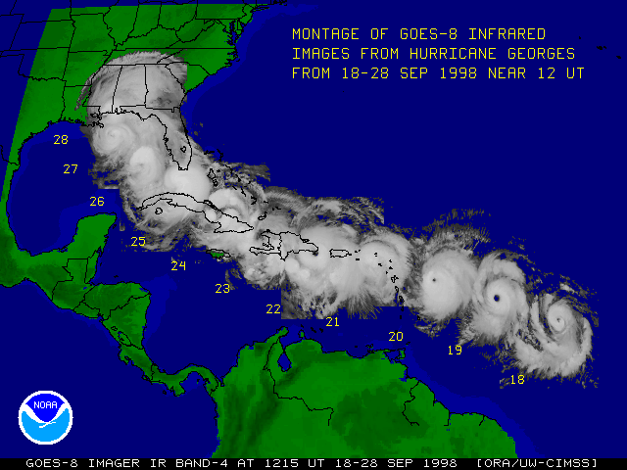
Figure 1. Satellite montage showing the track of Hurricane Georges (1998) as it passed through the Caribbean, making landfall on many islands. Image developed by researchers at CIMSS (Cooperative Institute of Meteorological Satellite Studies) and available from http://cimss.ssec.wisc.edu/tropic/archive/1998/storms/georges/mgeorg2.gif.

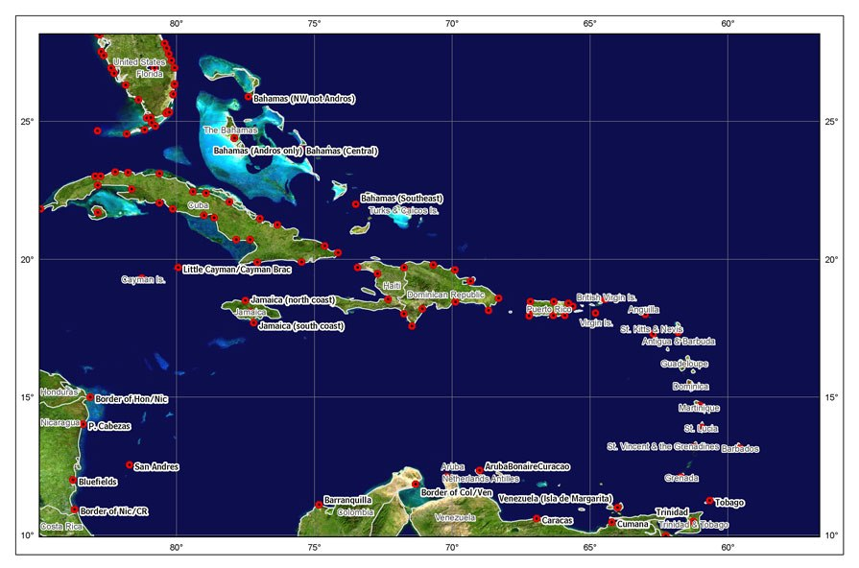
Figure 2. Caribbean region (10-27.5°N, 57.5-85°W) as used in the present study. In this study, we partition the region into western (west of 68°W) and eastern Caribbean as indicated on the map. Red symbols are breakpoints used by the US National Hurricane Center (NHC). Graphic is courtesy of National Hurricane Center (NHC).

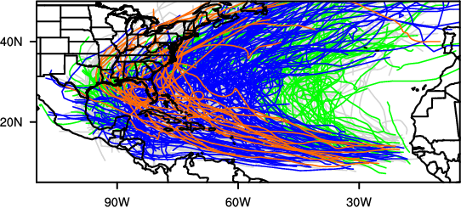 |  | 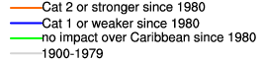
WESTERN CARIBBEAN TRACKS | EASTERN CARIBBEAN TRACKS
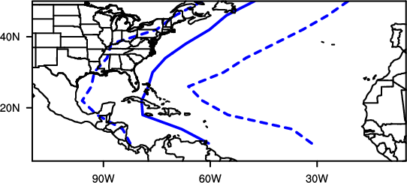 | 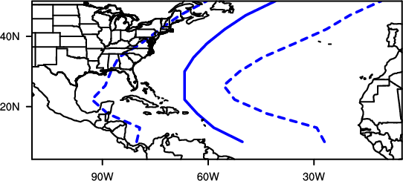
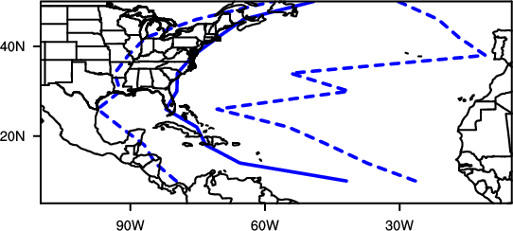 | 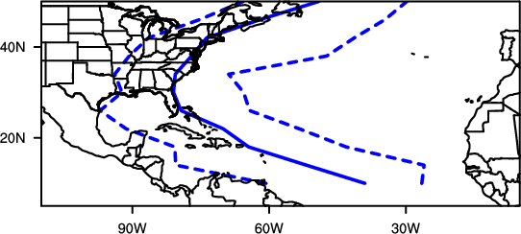
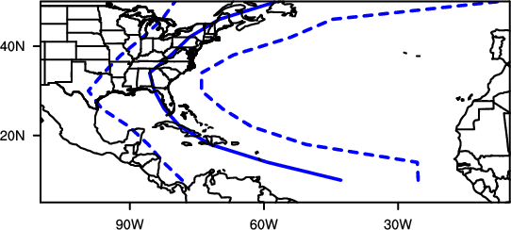 | 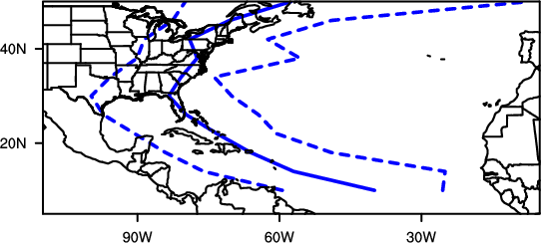

Figure 3. Tracks of tropical cyclones (TC) over the entire North Atlantic basin 1900-2009 (top); tropical cyclones occurring between 1900-1979 (the pre-satellite era) are plotted in grey. Tracks of TC occurring after 1979 are color coded based on their maximum intensity as they passed through the Caribbean as follows: weaker (tropical storm or category 1 hurricane) systems (blue); TC of at least category 2 intensity (red); and storms that had no impact in the Caribbean (green). Track ranges for TC+ category 1, category 2 and category 3-5 storms (going down) for the western and eastern Caribbean are plotted in the left and right columns respectively. The solid line is the mean track for the category and the dash lines bound the 95th percentile.

(a) | 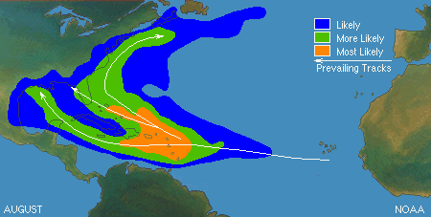
(b) | 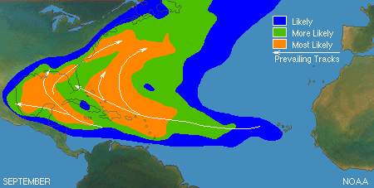
(c) | 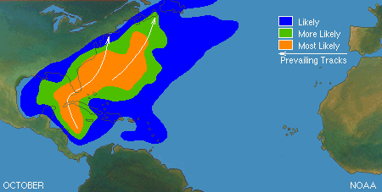

Figure 4. Storm track envelopes for months that are climatologically most likely to have TC impact on the Caribbean. Images courtesy of the US National Hurricane Center and available from http://www.nhc.noaa.gov/pastprofile.shtml#bac.

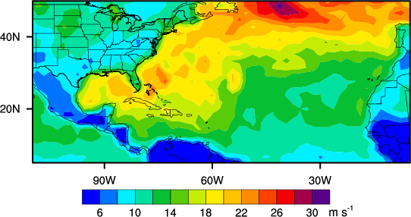
Figure 5. Map of the strongest surface wind speed at each location for days when a tropical storm was in the Caribbean basin. Wind speed is in meters per second (1 m s⁻¹ = 2.2 mph); tropical storms have winds exceeding 17 m s⁻¹ (yellow) and hurricanes exceed 33 m s⁻¹ (purple). Winds plotted here are from a computer analysis of the observed winds that leads to smoothing of these winds; thus all values here represent lower bounds on the actual winds experienced at a given location.

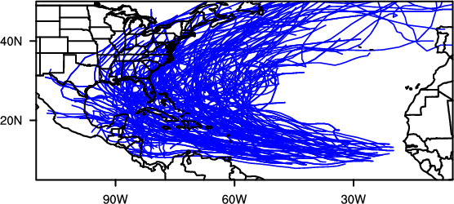
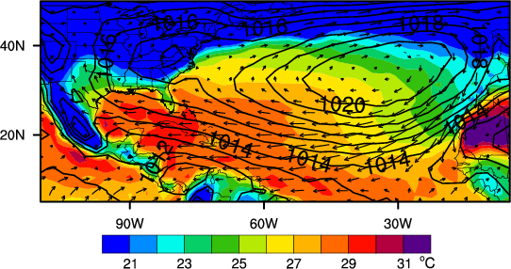

Figure 6. Analysis of tropical cyclones impacting the Caribbean basin in the 30-year period 1980-2009: (a) storm tracks; and (b) the tropical cyclone environment averaged over all August-September-October (ASO) 3-month periods in 1980-2009. Ocean surface temperature is shaded (°C), surface pressure is contoured (units of millibars) and average surface winds are drawn as vectors (i.e., arrows).

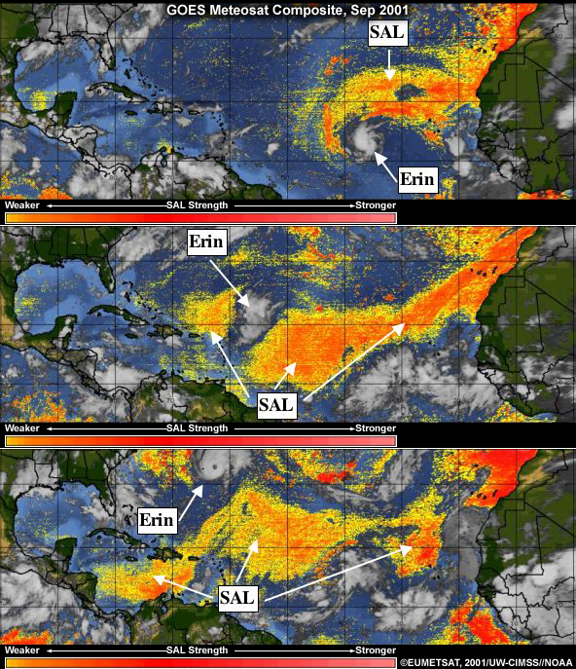

Figure 7. Satellite map showing the interaction between the dust layer associated with a Saharan Air Layer (SAL) event and Hurricane Erin (2001). Image originally published in Evans (2010). The operational product depicted here is documented in the paper by Dunion and Velden (2004) and is available from http://cimss.ssec.wisc.edu/tropic2/real-time/salmain.php?&prod=splitE&time.

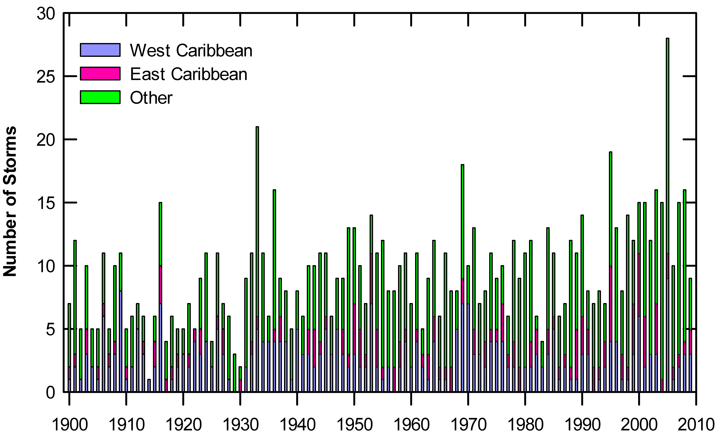
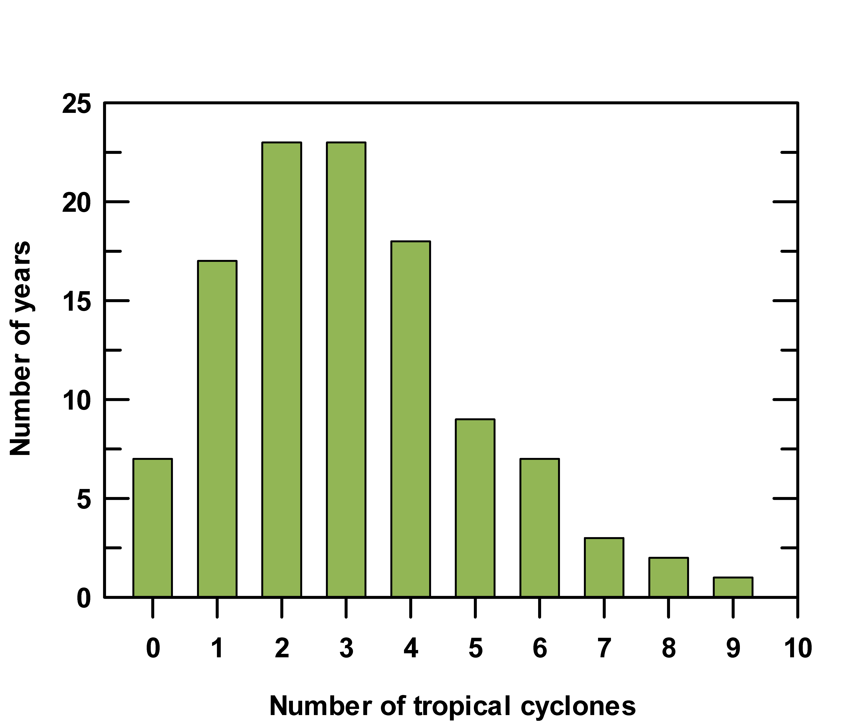 | 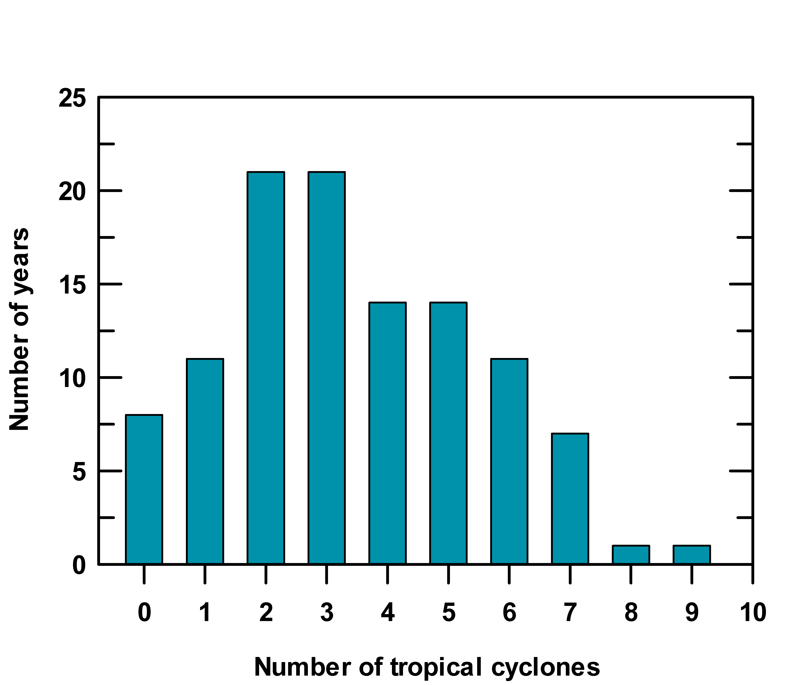

Figure 8. Analyses of annual tropical cyclone activity: (a) Annual tropical cyclone frequency for 1900-2009 in the western (blue) and eastern (red) Caribbean regions and the remainder of the North Atlantic basin (green). TCs impacting both western and eastern Caribbean domains are attributed to the first region they entered and so are only counted once. The total for each year is represented by the three colors combined. Bottom panels are the probability distributions of annual tropical cyclone frequency for the western (left) and eastern (right) Caribbean.

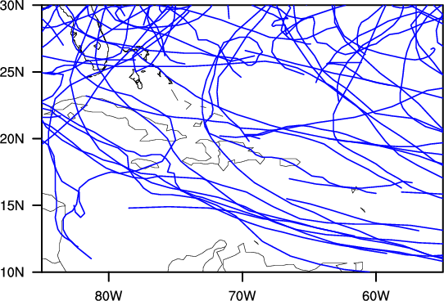
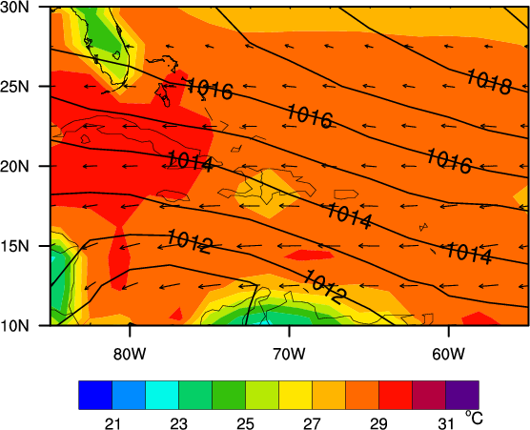
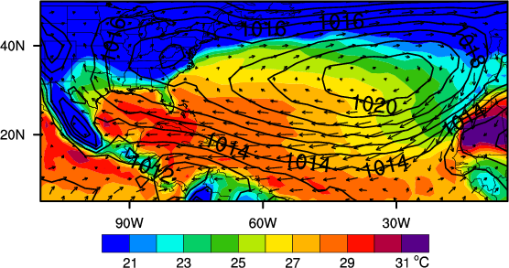

Figure 9. Focus on the Caribbean: (a) tracks of all TCs impacting the Caribbean restricted only to ENSO years (Table 1) within the period 1980-2009; and (b) ocean surface temperature (shaded; °C), and surface pressure (contours; millibars) averaged over the August-September-October (ASO) 3-month periods for the same set of ENSO years listed in Table 1. (c) as in (b), but for the entire North Atlantic basin.

Figure 10. Decadal tropical cyclone activity for 1900-2009 in (a) western and (b) eastern Caribbean regions. The number of years in each decade designated as ENSO events is indicated by the line with the scale on the right axis (Table 1).

TABLES
Table 1. ENSO years within the period 1950-2009 used to compile the statistics in Fig 10. Years from 1980 forward were used for the composites depicted in Fig. 9. ENSO years designated as “strong” are indicated in bold, while italics signify “moderate” ENSO events.

Decade | Years used in ENSO diagnostics
1950−1959 | 1951  1957
1960−1969 | 1963  1965  1968  1969
1970−1979 | 1972  1976  1977
1980−1989 | 1982  1986  1987
1990−1999 | 1991  1992  1994  1997
2000−2009 | 2002  2004  2006  2009

Table 2. Projected changes in tropical cyclones across the globe associated with a warming of the climate. The IPCC expresses confidence in their projections. Their terminology equating to probability of occurrence is explained in the text (section 5.1). Confidence in projections for global changes in tropical cyclone characteristics ranges from medium to likely as listed in this table. A GCM refers to high-resolution atmospheric global climate models; these models do not have direct ocean feedbacks.

Increase in peak wind intensities likely
Over most tropical cyclone areas (based upon high-resolution AGCM and embedded hurricane model projections)

Increase in mean and peak precipitation intensities likely
Over most tropical cyclone areas (based upon high-resolution AGCM and embedded hurricane model projections)

Changes in frequency of occurrence medium confidence
Decrease in number of weak storms, increase in number of strong storms (based upon some high-resolution AGCM projections)
Globally averaged decrease in number, but specific regional changes dependent on sea surface temperature change (based upon several climate model projections)
Possible increase over the North Atlantic (based on the studies of Sugi et al. 2002 and Oouchi et al. 2006)

Tropical cyclones occurring outside the North Atlantic or eastern North Pacific basins are classified by other regional tropical cyclone warning centers.
Hurricane categories are defined in the Saffir-Simpson hurricane scale, first developed in the 1950s by Herb Saffir, an engineer, and Bob Simpson, then Director of the National Hurricane Laboratory.
Warm ocean conditions, thunderstorm activity and winds nearly constant with height.
Spatial footprint of ocean basin or even global scales; timescales of years or longer.

